SOLAR PV MODELLING PROJECT IMAGES

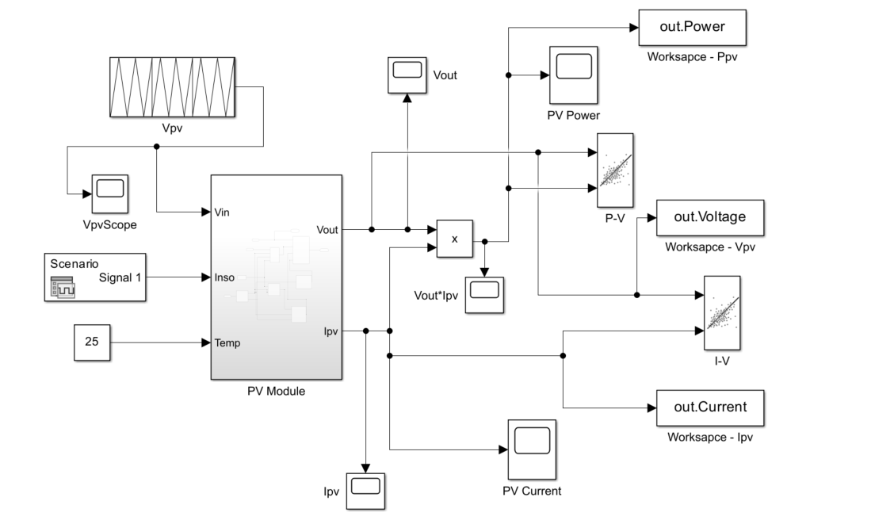
Figure 1. Top-level Simulink model of the PV module system

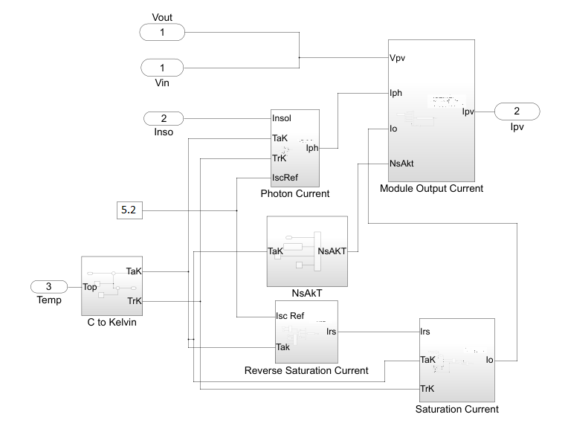
Figure 2. Inside the ‘PV Module’ showing six key parameter blocks.

SUBSYSTEM
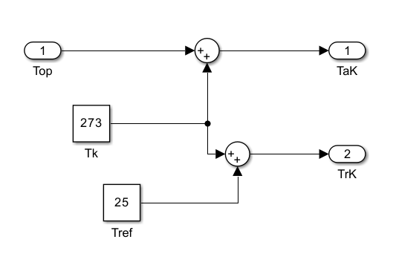
Figure 3. Temperature conversion from °C to Kelvin.

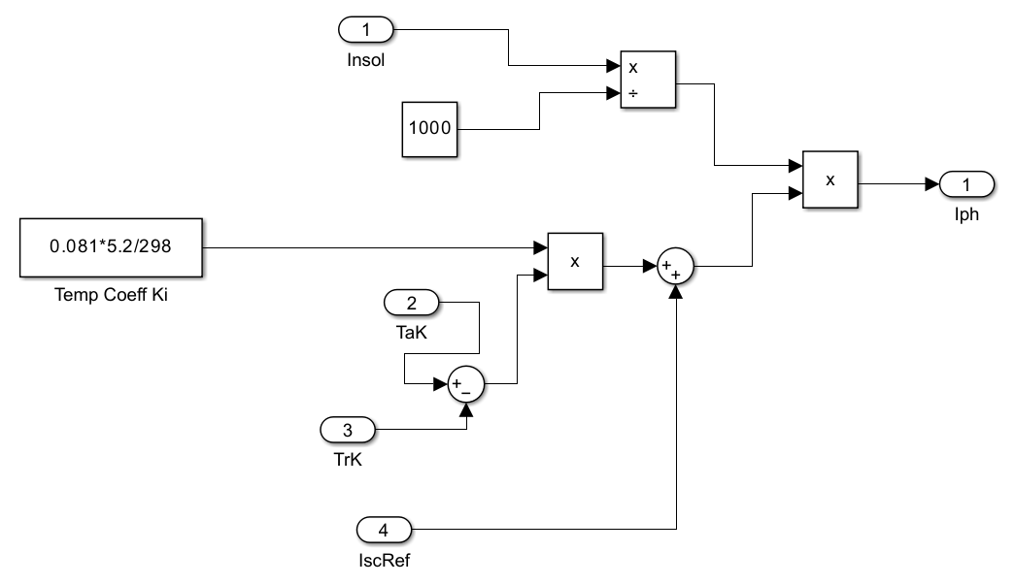
Figure 4: Photon Current Subsystem Block
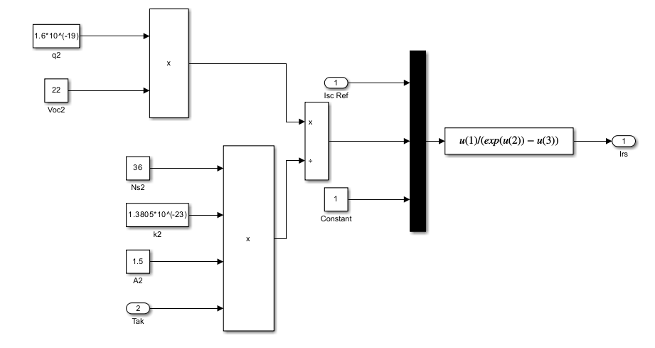
Figure 5: Reverse Saturation Current Subsystem Block

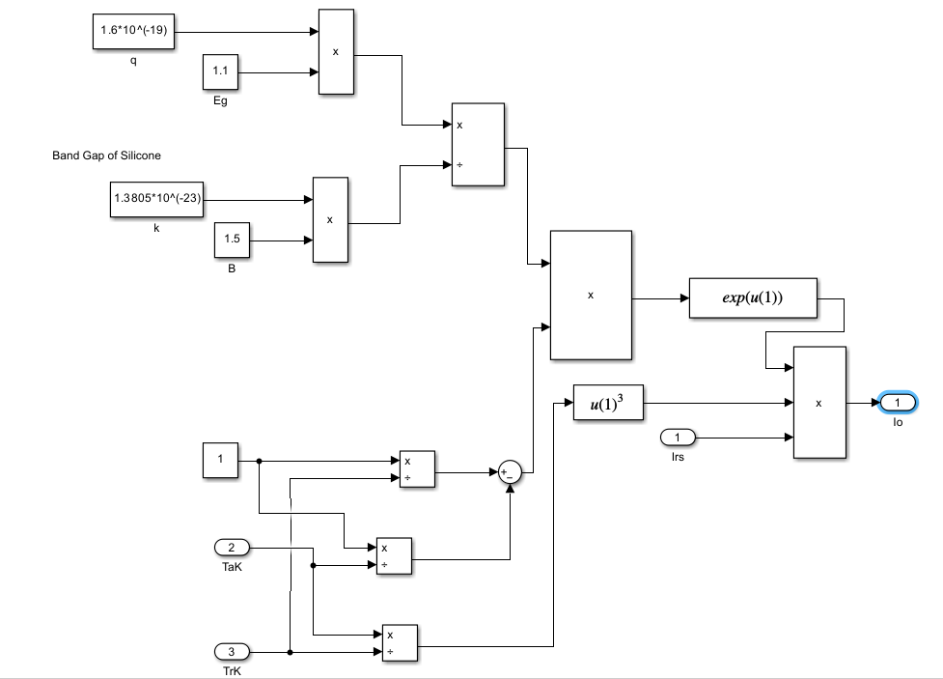
Figure 6: Saturation Current Subsystem Block
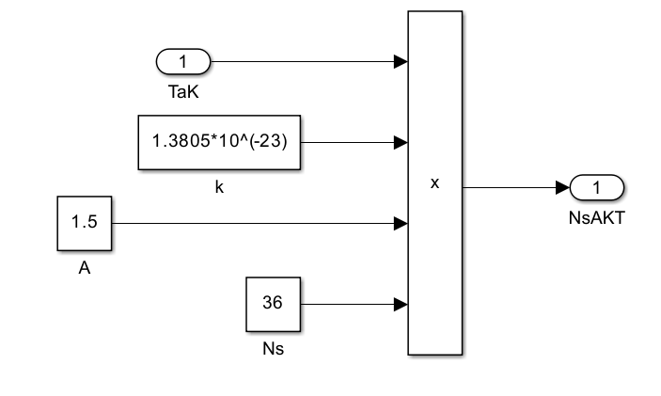
Figure 7: NsAKT (Thermal Voltage) Subsystem Block
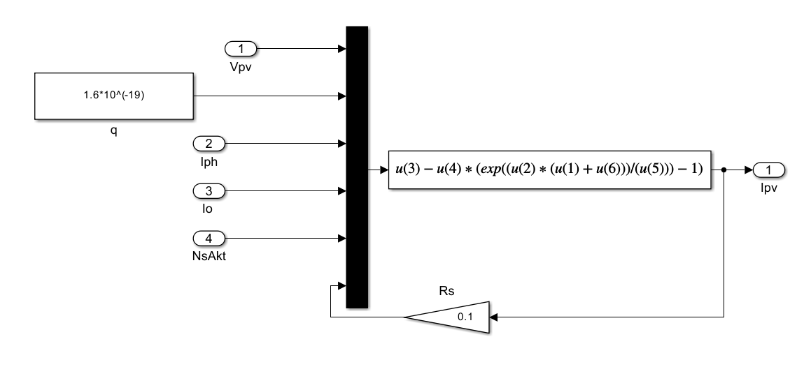
Figure 8: Output Current Subsystem Block

Figure 9: I–V characteristics of the PV module at varying irradiance levels.

Figure 10: P–V characteristics showing increased power generation.
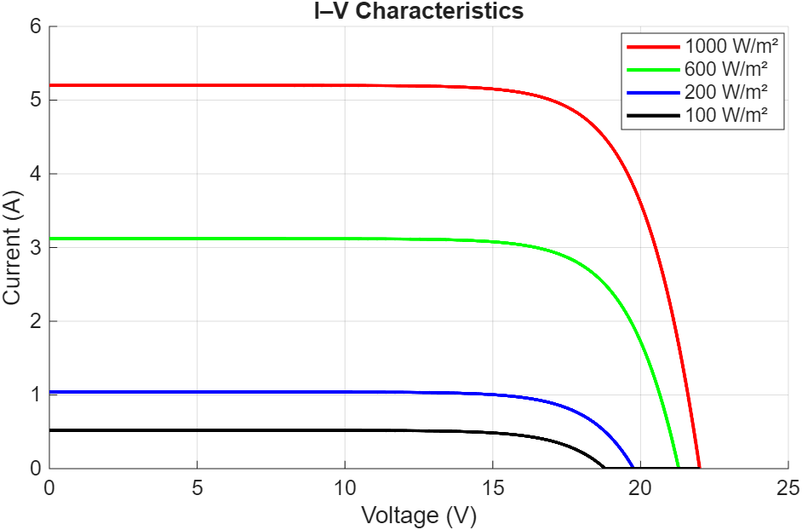
Figure 11: Simulated current–voltage (I–V) characteristics of the PV module for irradiance levels of 100, 200, 600, and 1000 W/m².

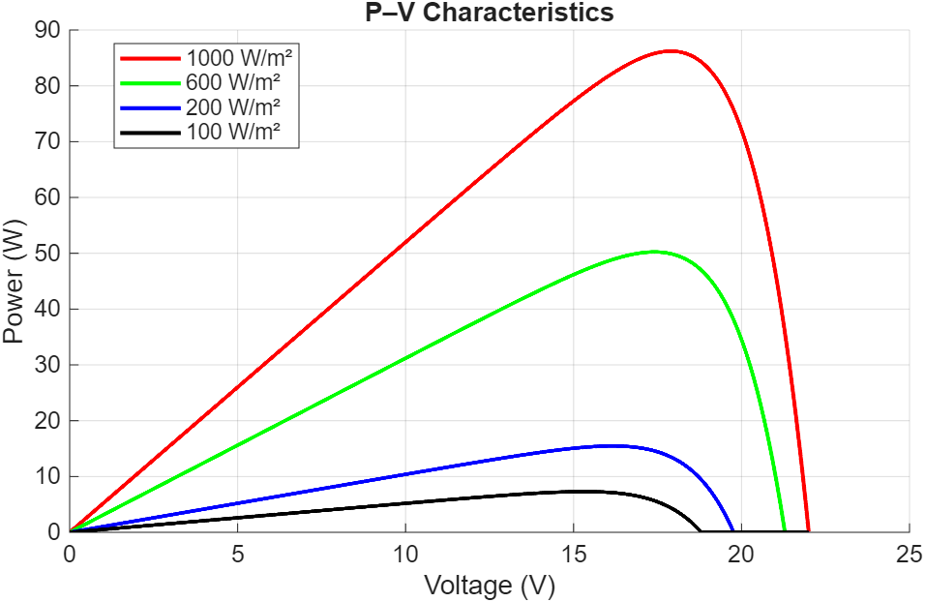
Figure 12: Simulated power–voltage (P–V) characteristics of the PV module for irradiance levels of 100, 200, 600, and 1000 W/m².

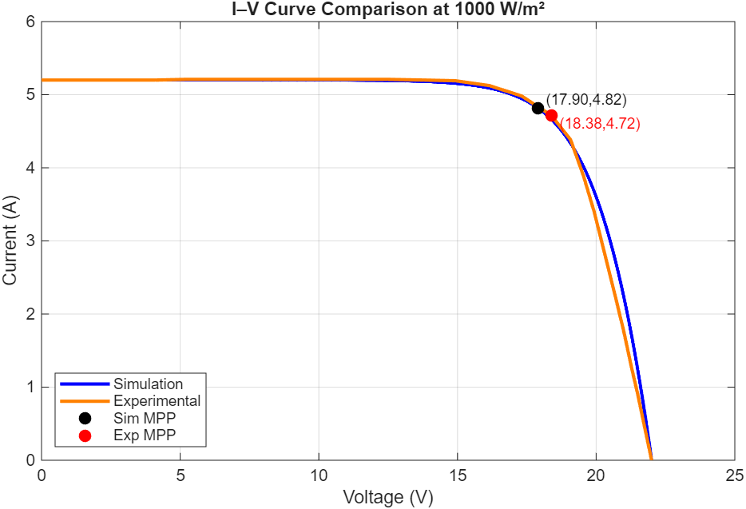
Figure 13: Comparison between Simulated and Experimental I–V Curves at 1000 W/m².

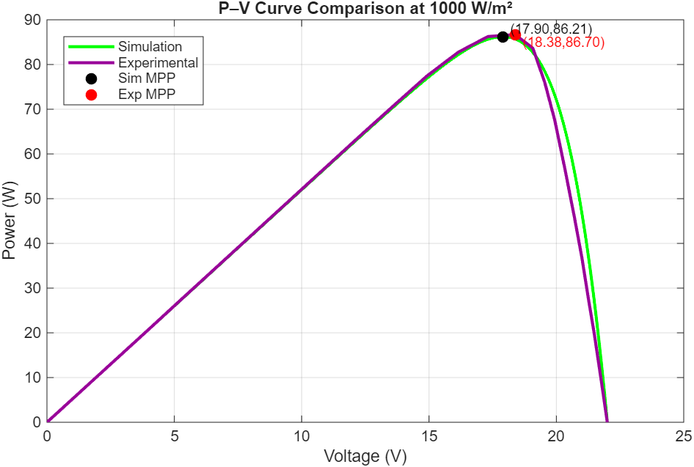
Figure 14: Comparison between Simulated and Experimental P–V Curves at 1000 W/m².
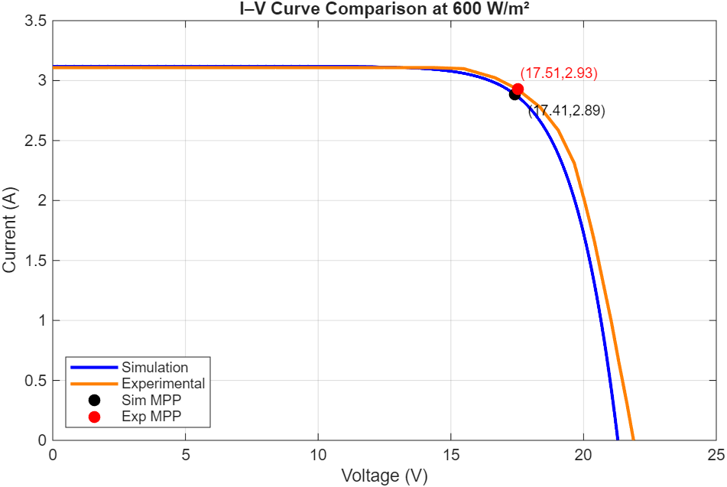
Figure 15: Comparison between Simulated and Experimental I–V Curves at 600 W/m².

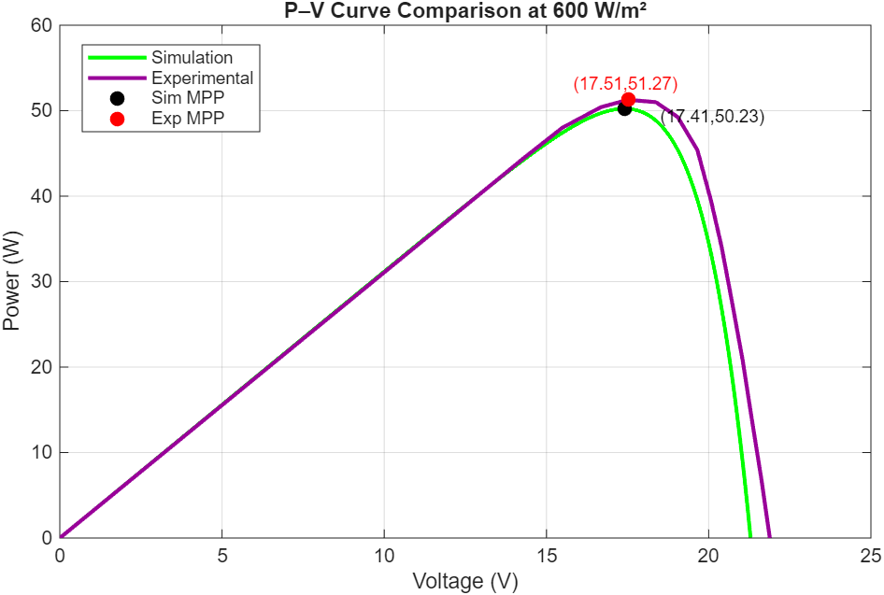
Figure 16: Comparison between Simulated and Experimental P–V Curves at 600 W/m².
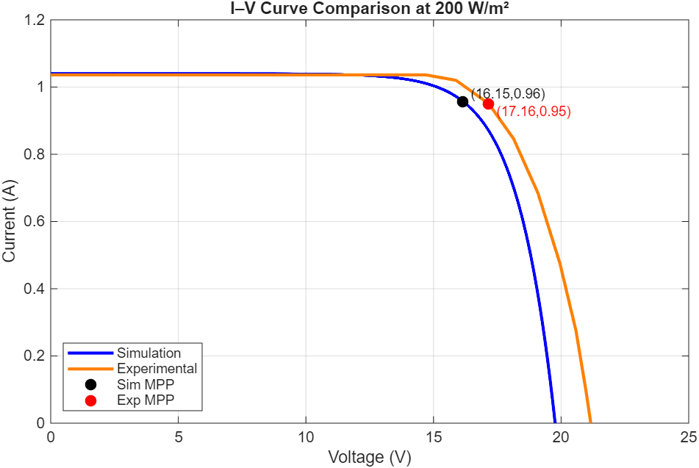
Figure 17: Comparison between Simulated and Experimental I–V Curves at 200 W/m².

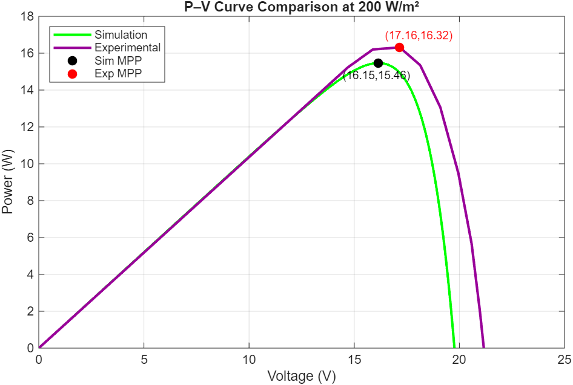
Figure 18: Comparison between Simulated and Experimental P–V Curves at 200 W/m².

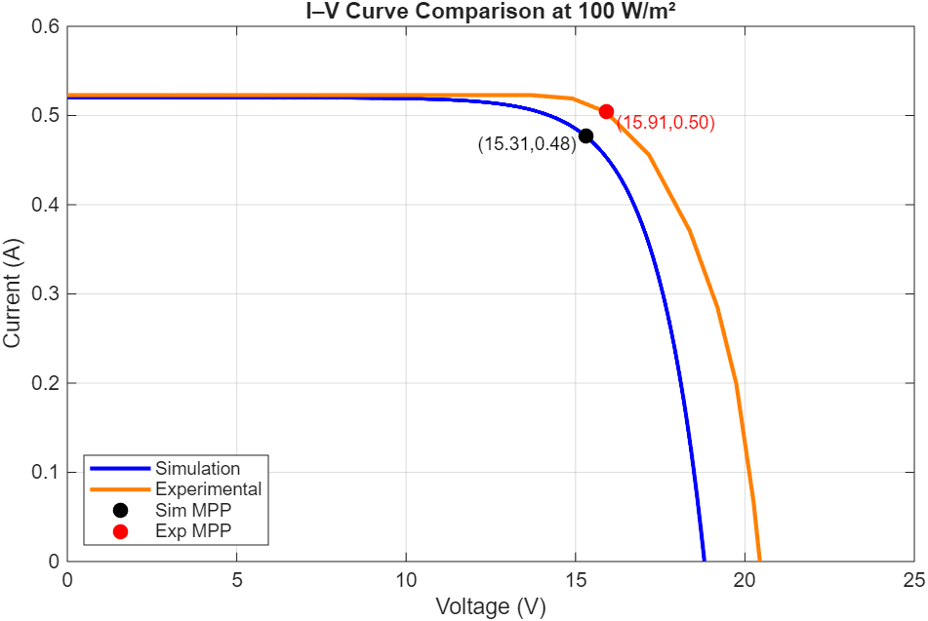
Figure 19: Comparison between Simulated and Experimental I–V Curves at 100 W/m².

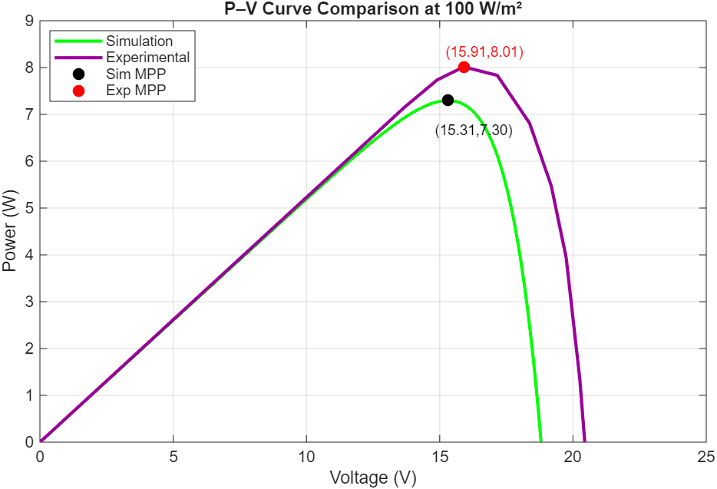
Figure 20: Comparison between Simulated and Experimental P–V Curves at 100 W/m².

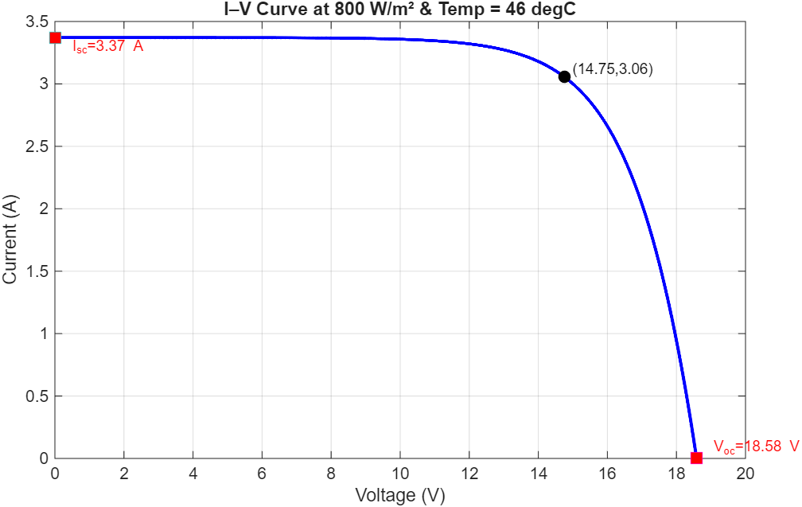
Figure 21: Simulated I–V curve at 800 W/m² and 46°C

